



Corporate Headquarters
ePlus Technology, Inc.
13595 Dulles Technology Drive
Herndon, VA 20171

Dhanuka Agritech Ltd
HCI Implementation Design Document

Version 1.0
May 2024s

COPYRIGHT AND TRADEMARKS
ePlus®, Where Technology Means More®, and ePlus products referenced herein are either registered trademarks or trademarks of ePlus Inc. in the United States and/or other countries. The names of other companies, products, and services mentioned herein may be the trademarks of their respective owners.

CONFIDENTIALITY STATEMENT
All information contained within this document is confidential and proprietary to ePlus. This document has been prepared specifically for sole use of the recipient. All rights, title, and interest in and to the information are and shall remain the sole and exclusive property of ePlus. It is not to be used, copied, scanned, distributed, or disclosed in whole or in part, without the written permission of ePlus. Reproduction by any means without prior written permission of ePlus is prohibited by law.

DISCLAIMER
This material has been prepared for and is intended to be used as a reference guide. The materials are for general information and educational purposes and are not intended to be exhaustive. No effort has been made to state or summarize all the requirements and issues that may be applicable to any given engagement or project. Because of the complexity of system configuration engagements, as well as variations in practices and procedures, this material should not be used as a substitute for professional services. On the basis of the foregoing, ePlus shall have no liability for any loss, costs, or damages of whatever kind of nature arising from or in connection with the use of this material. By reviewing this material, you agree that the information provided herein shall in no way be construed to be professional services advice and that you have no right to rely on any of the material contained herein for your installation.

PREFACE
This Implementation and Operational Run book document addresses the process and procedure to deploy, maintain and operate the Cisco UCS Nutanix.

INTENDED AUDIENCE
This document is intended for Dhanuka Agritech operations personnel or other authorized employees who are responsible for maintaining Cisco UCS Director Private Cloud Solution.

DOCUMENT CONTROL
Author | Nilesh Gaikwad, Thejesh Balakrishnan
Change Authority | ePlus Technology, Inc.

Version No. | Issue Date | Status
1.0 | 17th May 2024 | Initial Draft
1.1 | 22nd May 2024 | Updated the port details, Downloads, Foundation VM Resource requirements
1.2

TABLE OF Contents
PREFACE 3
INTENDED AUDIENCE 3
DOCUMENT CONTROL 3
1 INTRODUCTION 1
2 LOGICAL NETWORK 1
3 AHV NETWORK DESIGN 1
3.1 Open vSwitch 1
3.2 Bridges 1
3.3 Virtual Switch 1
3.4 Ports 1
3.5 Bonds 1
3.6 Flow Virtual Networking Architecture 3
3.7 Pre-Requisites 4
3.7.1 Network Requirements 4
3.7.2 Network Topology 4
3.7.3 Port Opening Matrix 5
VLAN Requirements 6
3.8 Uplink Port Mapping 6
3.8.1 Fabric to Leaf Switch 6
3.9 Server connections 7
3.9.1 Connectivity Diagram 7
3.9.2 Port Channel 7
3.9.3 Fabric to Server Port 7
3.9.4 Rack Diagram 8
4 BILL OF MATERIALS 9
4.1 Hardware 9
4.1.1 UCS Manager: 9
4.1.2 Nutanix Node: 9
4.2 Software 10
4.2.1 Nutanix and Cisco Intersight: 10
5 UCS Nutanix Cluster 10
5.1 UCS Manager Configuration 10
5.2 Nutanix Cluster Pre-Requisites 11
5.2.1 VLAN Information 11
5.2.2 IP Details – UCS Manager 11
5.2.3 UCSM Configuration Procedure 11
5.2.4 Discovering Cisco UCS Servers in Cisco UCS Manager 11
5.2.5 UCS Domain Mode Best Practices: 11
5.3 Installing the Foundation VM 12
5.3.1 Procedure 12
5.4 Initializing Foundation. 12
5.4.1 Before you begin 12
5.4.2 Procedure 12
5.5 Server Discovery, server configuration and Replication Factor Selection. 13
5.6 Upgradation of AOS and Hypervisor 13
5.7 Cluster Creation. 13
5.8 Post-Installation Task. 13
5.9 IP Details – Nutanix Cluster 14
5.10 Components Used 15
5.11 Prism Central Configuration 17
6 DOS AND DON’TS IN CISCO UCS NUTANIX ENVIRONMENT 17
7 INTERSIGHT 18
7.1 Introduction 18
7.2 1.1 Target Claim 19
8 Nutanix Move 19
8.1.1 Management server 19
8.1.2 Agents for source and target 19
8.1.3 Disk readers and writers 20
8.2 Nutanix Move for ESXI 20
8.3 Migration Using Nutanix Move 20
9 DOWNLOADS 22
9.1 CISCO UCS NUTANIX CLUSTER 22
9.2 UCS C220 M7 Server Firmware: 22
9.3 UCSM Managed C220 M7 Server Firmware: 22
10 Nutanix Foundation VM resource requirement for deployment: 23

INTRODUCTION
This document contains the low-level design and configuration details regarding Cisco UCS based Nutanix Deployment – 3 Nodes deployment, Intersight Saas integration and configurations. This document contains login credentials and IP Addresses that were used during the installation. Distribution of the document may be restricted as per end customer access policies. It is strongly recommended to change the initial passwords to customer standards after the implementation is complete.
Nutanix Platform is a powerful infrastructure solution that's secure, resilient, and adaptive. It supports diverse workloads across public and private clouds, the edge, multiple hypervisors and container platforms, and varied compute, storage, and network needs in your hybrid multicloud setup.
Cisco Intersight provides infrastructure management for Cisco Unified Compute System (Cisco UCS) and Cisco Nutanix platforms. This platform offers an intelligent level of management that enables IT organizations to analyse, simplify, and automate their environments in more advanced ways than previous generations of tools.

LOGICAL NETWORK
The Cisco Nutanix system has communication pathways that fall into four (2) defined zones:
- Management and CVM Zone —This zone comprises the connections needed to manage the physical hardware, the hypervisor hosts, and the storage platform controller virtual machines (SCVM). These interfaces and IP addresses need to be available to all staff who will administer the HCI system, throughout the LAN/WAN. This zone must provide access to Domain Name System (DNS) and Network Time Protocol (NTP) services and allow Secure Shell (SSH) communication.
- VM Zone —This zone comprises the connections needed to service network IO to the guest VMs that will run inside the Nutanix hyperconverged system. This zone typically contains multiple VLANs, that are trunked to the Cisco UCS Fabric Interconnects through the network uplinks and tagged with 802.1Q VLAN IDs. These interfaces and IP addresses need to be available to all staff and other computer endpoints which need to communicate with the guest VMs in the HCI system, throughout the LAN/WAN.

AHV NETWORK DESIGN
Nutanix AHV uses Open vSwitch (OVS) to connect the CVM, the hypervisor, and guest VMs to each other and to the physical network on each node. The CVM manages the OVS inside the AHV host. Don't allow any external tool to modify the OVS.

Open vSwitch
OVS is an open source software switch designed to work in a multiserver virtualization environment. In Nutanix AHV VLAN-backed networks, the OVS behaves like a layer 2 learning switch that maintains a MAC address table. The hypervisor host and VMs connect to virtual ports on the switch.
Nutanix AHV exposes many popular OVS features through the Prism GUI, such as VLAN tagging, load balancing, and link aggregation control protocol (LACP).

Bridges
A bridge switches traffic between physical and virtual network interfaces. The default Nutanix AHV configuration includes an OVS bridge called br0 and a native Linux bridge called virbr0. The virbr0 Linux bridge carries management and storage communication between the CVM and AHV host. All other storage, host, and VM network traffic flows through the br0 OVS bridge by default. The AHV host, VMs, and physical interfaces use ports for connectivity to the bridge.

Virtual Switch
In Nutanix AOS versions 5.19 and later, you can use a virtual switch to manage multiple bridges and uplinks in Prism.
We designed the virtual switch configuration to provide flexibility in configuring virtual bridge connections. A virtual switch defines a collection of AHV nodes and the uplink ports on each node. It aggregates similar OVS bridges on all the AHV nodes in a cluster. For example, vs0 is the default virtual switch and aggregates the br0 bridges and br0-up uplinks from all the nodes.

Ports
Ports are logical constructs created in a bridge that represent connectivity to the virtual switch. Nutanix uses several port types:
- An internal port—with the same name as the default bridge (br0)—acts as the AHV host management interface.
- Tap ports connect VM virtual NICs (vNICs) to the bridge.
- VXLAN ports are only used for the IP address management (IPAM) functionality provided by AHV.
- Bonded ports provide NIC teaming for the physical interfaces of the AHV host.

Bonds
Bonded ports aggregate the physical interfaces on the AHV host for fault tolerance and load balancing. By default, the system creates a bond named br0-up in bridge br0 containing all physical interfaces. Changes to the default bond (br0-up) using manage_ovs commands can rename it to bond0 when using older examples, so your system might be named differently than the following diagram. Nutanix recommends using the name br0-up to quickly identify this interface as the bridge br0 uplink. Using this naming scheme, you can also easily distinguish uplinks for additional bridges from each other.
OVS bonds allow for several load-balancing modes to distribute traffic, including active-backup, balance-slb, and balance-tcp. Administrators can also activate LACP for a bond to negotiate link aggregation with a physical switch. During installation, the bond_mode defaults to active-backup, which is the configuration we recommend for ease of use.
The following diagram illustrates the networking configuration of a single host immediately after imaging. The best practice is to use only the 10 GbE or more NICs and to disconnect the 1 GbE NICs if you don't need them. For additional information on bonds, refer to the Nutanix AHV Networking Best Practices section.
.
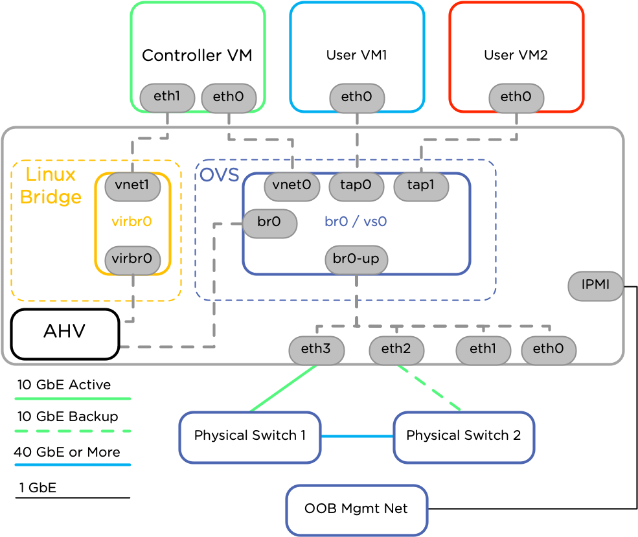
- AHV Network Design

Flow Virtual Networking Architecture
Flow Virtual Networking lets you create integrated software-defined networks and virtual private cloud capabilities and provides software-defined networking with multi-tenant isolation, self-service provisioning, and IP address preservation. The Flow Virtual Networking architecture uses a three-plane approach to simplify network virtualization.
Flow Virtual Networking provides a software-defined networking (SDN) solution with the three-plane architecture that SDN is built with. Flow Virtual Networking as SDN follows the following three-plane architecture:
- The Management Plane
The Management Plane provides the interface between you and the configuration and management interfaces. Primarily, it allows you to configure, manage, and monitor the virtual network resources such as IP addresses, subnets, routes and protocols.
Prism Central provides the Management Plane for Flow Virtual Networking. The Network & Security entity provides the Flow Virtual Networking components like Subnets, Virtual Private Clouds, Floating IPs, and Connectivity (which encompasses network gateways, connections like VPN or VTEP or BGP sessions.) Prism Central also allows you to control access to these virtual networking components on Prism Central using Role-based access control (RBAC).
- The Control Plane:
This plane is defined by the SDN controller. This plane is essentially decoupled from the data plane. In other words, the appliance that houses the SDN controller is a different and separate entity from the one that houses the data transport network or the Data Plane.
In Flow Virtual Networking, the Control Plane is defined by the network controller. Prism Central enables the Microservices Infrastructure when you deploy Prism Central. The network controller is enabled on the Prism Central as containerized services using Microservices Infrastructure.
The network controller that allows you to create a virtual overlay network as an abstraction of the complex underlay network infrastructure. The network controller manages the network services and direct packet traffic throughout the network. The network controller, with the network gateway appliance, helps you manage the networks, connections (such as VPN and VTEP connections, and BGP sessions) and devices with ease.
In x-Large Prism Central, the network controller is automatically enabled when Prism Central is deployed. In Small and Large Prism Central deployments, you must enable the network controller manually.
The Data Plane
The Open vSwitch (OVS) deploys a collection of bridges within the AHV hosts. The traffic flows through these bridges between the AHV hosts. To configure and manage these bridges, AHV allows you to deploy virtual switches. AHV deploys a default virtual switch vs0 during the installation process. The default virtual switch manages the bridges br0 on all the AHV hosts in the cluster.
This OVS infrastructure on the AHV hosts provides the Data Plane for Flow Virtual Networking. See About Open vSwitch.
Ensure that all management, vMotion, and storage traffic are locally forwarded to the fabric interconnects to keep the flow in steady state. When vNIC-a fails, ESXi computes the load balancing, and all the virtual ports are re-pinned to vNIC-b. When vNIC-a comes back online, re-pinning does apply, and virtual ports are r rebalanced across vNIC-a and vNIC-b. This reduces the latency and bandwidth utilization upstream of the Cisco UCS fabric interconnects.
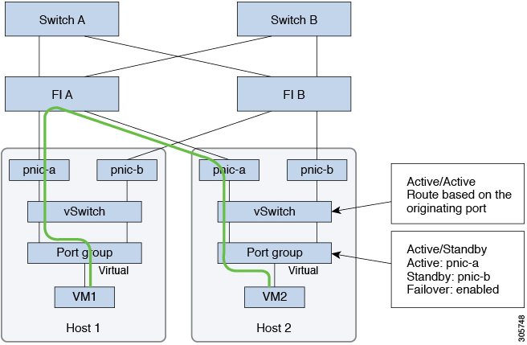
- Traffic Flow – Steady State

Pre-Requisites

Network Requirements
When configuring a Nutanix block, a set of IP addresses must be allocated to the cluster. Ensure that chosen IP addresses do not overlap with any hosts or services within the environment. You will also need to make sure to open the software ports that are used to manage cluster components and to enable communication between components such as the Controller VM, Web console, Prism Central, hypervisor, and Nutanix hardware. Nutanix recommends that you specify information such as a DNS server and NTP server even if the cluster is not connected to the Internet or runs in a non-production environment.

Customer Network
We will need the following information during the cluster configuration:
- Default gateway.
- Network mask.
- DNS server.
- NTP server.
Check whether a proxy server is in place in the network. To perform this check, you need the IP address and port number of that server when enabling Nutanix Support on the cluster.

New IP Addresses
Each node in a Nutanix cluster requires three IP addresses, one for each of the following components:
- IPMI interface
- Hypervisor host
- Nutanix Controller VM
All Controller VMs and hypervisor hosts must be on the same subnet. No systems other than the Controller VMs and hypervisor hosts can be on this network.

Network Topology
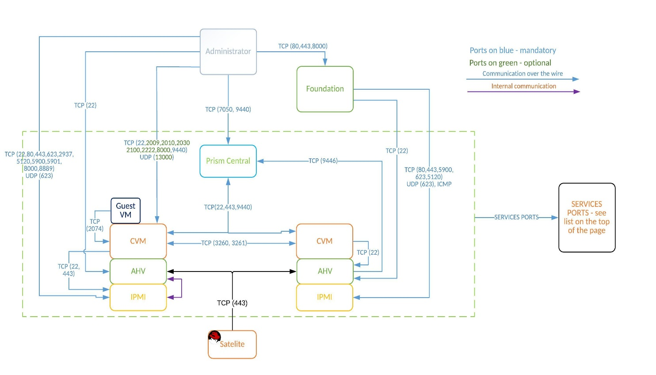
- Network Topology

Port Opening Matrix
Port Number | Protocol | source | Destination
22 | TCP | Jumphost System | AHV
22,80,443,  623,2937,5120,  5900,5901,8000,8889, | TCP | Jumphost System | IPMI
623 | UDP | Jumphost System | IPMI
22,2009,2010,  2100,2222,9440,8000 | TCP | Jumphost System | Controller VM / Prism Central / Cluster IP
13000 | UDP | Jumphost System | Controller VM / Prism Central / Cluster IP
80,443,8000 | TCP | Jumphost System | Foundation
9440,7050 | TCP | Jumphost System | Prism Central
9440,7050 | TCP | Prism Central | Jumphost System
9446 | TCp | Prism Central | AHV
22,443,9440 | TCP | Prism Central | Controller VM / Prism Central / Cluster IP
80,443,8000 | TCP | Foundation | Jumphost System
80,443,5900,623,5120 | TCP | Foundation | IPMI
623 | UDP | Foundation | IPMI
ICMP | ICMP | Foundation | IPMI
ICMP | ICMP | Foundation | Hypervisor
22,443,8000 | TCP | Foundation | Hypervisor
22 | TCP | Foundation | Controller VM / Prism Central / Cluster IP
ICMP | ICMP | Foundation | Controller VM / Prism Central / Cluster IP
14000,13000 | UDP | Foundation | Controller VM / Prism Central / Cluster IP
22 | TCP | Controller VM / Prism Central / Cluster IP | AHV
2074 | TCP | Controller VM / Prism Central / Cluster IP | Guest Vm Network
3260,3261 | TCP | Controller VM / Prism Central / Cluster IP | Controller VM / Prism Central / Cluster IP
22,443 |  | Controller VM / Prism Central / Cluster IP | IPMI
53 | TCP | DNS | Controller VM / Prism Central / Cluster IP
53 | TCP | DNS | Hypervisor
53 | TCP | DNS | IPMI
123 | TCP | NTP | Controller VM / Prism Central / Cluster IP
123 | TCP | NTP | Hypervisor
123 | TCP | NTP | IPMI
443 | TCP | Controller VM / Prism Central / Cluster IP | insights.nutanix.com
161,162 | TCP | Controller VM / Prism Central / Cluster IP | SNMP
161,162 | TCP | IPMI | SNMP
386,638 | TCP | Controller VM / Prism Central / Cluster IP | LDAP
25,587,465 | TCP | Controller VM / Prism Central / Cluster IP | SMTP server
80, 443 | TCP | Controller VM and Prism Central VM | download.nutanix.com
80, 443 | TCP | Controller VM and Prism Central VM | release-api.nutanix.com
80, 443 | TCP | Hypervisor Host | 169.254.3.0/24
80 | TCP | Controller VM or Prism Central | release-api.nutanix.com
80, 443 | TCP | Controller VM or Prism Central | download.nutanix.com
514 | TCP/UDP | Prism Element data service and Controller VM | Syslog

VLAN Requirements
IP addresses for nodes and cvms are required. Refer Section 5.9

Uplink Port Mapping

Fabric to Upstream Switch
Source | Port | Destination | Port
FI – A | 47 | SG-500-28P-SW1 | 11
FI – B | 47 | SG-500-28P-SW2 | 11
FI – A | 48 | SG-500-28P-SW1 | 12
FI – B | 48 | SG-500-28P-SW2 | 12

Server connections

Connectivity Diagram
- Physical Connectivity Diagram

Port Channel Details
Source | Port | Destination | Port | Port Channel
FI-A | 47 | SG-500-28 – SW1 | 11 | PO10
FI-A | 48 | SG-500-28 -SW2 | 11 | PO10
FI-B | 47 | SG-500-28 – SW1 | 12 | PO20
FI-B | 48 | SG-500-28 – SW2 | 12 | PO20

Fabric to Server Port
Source | Port | Destination | Port
FI – A | 17 | Server 1 | 1
FI – A | 18 | Server 2 | 1
FI – A | 19 | Server 3 | 1
FI – A | 20 | Server 1 | 2
FI – A | 21 | Server 2 | 2
FI – A | 22 | Server 3 | 2
FI – B | 17 | Server 1 | 1
FI – B | 18 | Server 2 | 1
FI – B | 19 | Server 3 | 1
FI – B | 20 | Server 1 | 2
FI – B | 21 | Server 2 | 2
FI – B | 22 | Server 3 | 2
FI-A | L1 | FI-B | L1
FI-A | L2 | FI-B | L2
FI-A | Management | SG500-28P | 11, 12
FI-B | Management | SG500-28P | 11, 12

Rack Diagram
- Rack Diagram

BILL OF MATERIALS

Hardware

UCS Manager:
PID | Description | Qty
HCI-FI-6454 | Cisco Compute Hyperconverged Fabric Interconnect 6454 | 2
CON-SNTP-HCIFI6HW | SNTC-24X7X4 Cisco Compute Hyperconverged Fabric Inte | 2
HCI-UCSM-MODE | UCSM Deployment mode for FI | 2
N10-MGT018 | UCS Manager v4.2 and Intersight Managed Mode v4.2 | 2
HCI-PSU-6332-AC | UCS 6332/ 6454 Power Supply/100-240VAC | 4
CAB-C13-C14-3M-IN | Power Cord Jumper, C13-C14 Connectors, 3 Meter Length, India | 4
SFP-H25G-CU3M | 25GBASE-CU SFP28 Cable 3 Meter | 12
QSFP-40/100-SRBD | 100G and 40GBASE SR-BiDi QSFP Transceiver, LC, 100m OM4 MMF | 4
UCS-ACC-6332 | UCS 6332/ 6454 Chassis Accessory Kit | 2
UCS-FAN-6332 | UCS 6332/ 6454 Fan Module | 8

Nutanix Node:
PID | Description | Qty
sHCIAF220C-M7S | Cisco Compute Hyperconverged HCIAF220cM7 All Flash Node | 3
CON-SNTP-HCIAF22C | SNTC-24X7X4 Cisco Compute Hyperconverged HCIAF220cM7 | 3
HCI-FI-MANAGED | Deployment mode for Server Managed by FI | 3
HCI-SAS-M7T | Cisco M7 12G SAS HBA for (16 Drives) | 3
HCI-SD38TBM1X-EV | 3.8TB 2.5in Enter Value 6G SATA Micron G2 SSD | 9
HCI-M2-240G | 240GB M.2 SATA Micron G2 SSD | 6
HCI-M2-HWRAID | Cisco Boot optimized M.2 Raid controller | 3
HCI-RAIL-M7 | Ball Bearing Rail Kit for C220 & C240 M7 rack servers | 3
HCI-TPM-002C | TPM 2.0, TCG, FIPS140-2, CC EAL4+ Certified, for servers | 3
HCI-AOSAHV-67-SWK9 | HCI AOS AHV 6.7 SW | 3
UCSC-HSLP-C220M7 | UCS C220 M7 Heatsink for & C240 GPU Heatsink | 6
UCSC-BBLKD-M7 | UCS C-Series M7 SFF drive blanking panel | 21
UCS-DDR5-BLK | UCS DDR5 DIMM Blanks | 48
UCSC-RDBKT-22XM7 | UCS C-Series M7 1U RAID/HBA Controller Bracket | 3
CBL-SAS-C220M7 | C220M7 SAS CABLE; MB CPU1 P-1 to PB | 3
HCI-CPU-I5418Y | Intel I5418Y 2GHz/185W 24C/45MB DDR5 4400MT/s | 6
HCI-MRX16G1RE1 | 16GB DDR5-4800 RDIMM 1Rx8 (16Gb) | 48
HCI-RIS1A-22XM7 | UCS C-Series M7 1U Riser 1A PCIe Gen4 x16 HH | 3
HCI-RIS2A-22XM7 | UCS C-Series M7 1U Riser 2A PCIe Gen4 x16 HH | 3
HCI-RIS3C-22XM7 | UCS C-Series M7 1U Riser 3C PCIe Gen5 x16 FH (CPU2) | 3
HCI-MLOM | HCI MLOM Connectivity | 3
HCI-M-V5Q50G | Cisco VIC 15428 4x 10/25/50G mLOM C-Series | 3
HCI-PSU1-1600W | UCS 1600W AC PSU Platinum (Not EU/UK Lot 9 Compliant) | 6
CAB-C13-C14-3M-IN | Power Cord Jumper, C13-C14 Connectors, 3 Meter Length, India | 6

Software

Nutanix and Cisco Intersight:
PID | Description | Qty
HCI-M7-MLB | Cisco Compute Hyperconverged M7 with Nutanix MLB | 1
NTX-SW | Nutanix Software 3Y and above | 1
NT-NCI-STR-PR | NCI Starter SW LIC & Production SW Supp per Core | 144
SVS-NT-SUP | Entitlement ONLY for Nutanix Cloud Infrastructure SW | 1
DC-MGT-SAAS | Cisco Intersight SaaS | 1
DC-MGT-IS-SAAS-ES | Infrastructure Services SaaS/CVA - Essentials | 3
SVS-DCM-SUPT-BAS | Basic Support for DCM | 1
DC-MGT-UCSC-1S | UCS Central Per Server - 1 Server License | 3

UCS Nutanix Cluster

UCS Manager Configuration
Cisco UCS Manager is the management system for all components in a UCS Manager. Cisco UCS Manager runs within the fabric interconnect. You can use any of the interfaces available with this management service to access, configure, administer, and monitor the network and server resources for all chassis connected to the fabric interconnect. Multiple Management Interfaces Cisco UCS Manager includes the following interfaces you can use to manage a Cisco UCS domain:
- Cisco UCS Manager GUI
- Cisco UCS Manager CLI
- XML API
- KVM
- IPMI
Almost all tasks can be performed in any of the interfaces, and the results of tasks performed in one interface are automatically displayed in another. However, you cannot do the following:
- Use Cisco UCS Manager GUI to invoke Cisco UCS Manager CLI.
- View the results of a command invoked through Cisco UCS Manager CLI in Cisco UCS Manager GUI.
- Generate CLI output from Cisco UCS Manager GUI.
The Cisco UCS 6454 54-Port Fabric Interconnect is a One-Rack-Unit (1RU) 10/25/40/100 Gigabit Ethernet, FCoE, and Fibre Channel switch offering up to 3.82 Tbps throughput and up to 54 ports. The switch has 28 10/25-Gbps Ethernet ports, 4 1/10/25- Gbps Ethernet ports, 6 40/100-Gbps Ethernet uplink ports, and 16 unified ports that can support 10/25-Gbps Ethernet ports or 8/16/32-Gbps Fibre Channel ports. All Ethernet ports are capable of supporting FCoE.Port configuration of FI 6454:

Sl. No. | Description
 | Ports 1-16 (Unified port support 10/25 Gbps Ethernet or FCoE or 8/16/32 Gbps FC)
 | Ports 17-44 (10/25 Gbps Ethernet or FCoE)
 | Ports 45-48 (1/10/25 Gbps Ethernet or FCoE)
 | Ports 49-54 (40/100 Gbps Ethernet or FCoE)

Front View:
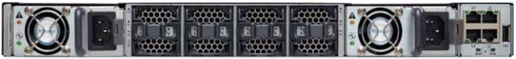
- Fabric Interconnect Front View

Rear View:
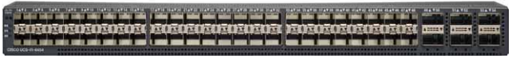
- Fabric Interconnect Rear View
The fabric interconnect runs both NXOS (limited) and UCS OS.

Nutanix Cluster Pre-Requisites
The prerequisite for the Nutanix cluster is as below.

VLAN Information
Network | VLAN ID | VLAN NAME | Comments
VLAN for CVM and AHV management | 1 | Management_VLAN | Used for management traffic between Foundation VM, AHV and Prism
VLAN for IPMI/OOB | 1 | IPMI / OOB | User For managing your device's hardware at the motherboard level
VLAN for VM Network | 1 | VM_VLAN | Used for VM/Application network. Must be routable

IP Details – UCS Manager
Site A
Uplink Switch Model | G500-28P
UCS Management Cluster IP Address | 10.240.251.80
UCS FI-A IP Address | 10.240.251.81
UCS FI-B IP Address | 10.240.251.82
Pool for KVM IPs (One per Nutanix node is required) | 10.240.251.91-93
Subnet mask | 255.255.255.128
Default gateway | 10.240.251.1
MAC pool prefix` | B1
User ID | admin
Password | P@ssw0rd

Note: The MAC pool prefix must be verified by Customer

UCSM Configuration Procedure
Perform the initial network connection and configuration of the fabric interconnects in the cluster mode.

Procedure
Connect the workstation to the serial console port labeled Console on the front panel of the fabric interconnects.
Connect the L1 and L2 ports of one fabric interconnect directly to the L1 and L2 ports on the other fabric interconnect (L1 to L1 and L2 to L2) using Ethernet cables.
This enables the fabric interconnects to function in a cluster mode.
Configure the serial console connection on the workstation and use that serial console connection to configure the fabric interconnects.
The first fabric interconnect FI-A is configured as primary, and the second fabric interconnect FIB is configured as Subordinate. The primary and secondary roles can change during maintenance operations.

Discovering Cisco UCS Servers in Cisco UCS Manager
You must discover the Cisco UCS servers in Cisco UCS Manager to start imaging the servers using Foundation.

Procedure
- Power on the servers and let the Cisco UCS Manager begin the discovery process.
- Once the discovery process is complete in the Cisco UCS Manager, ensure that each server is
available in an unassociated state.
- Make a note of the serial numbers of servers that you intend to use for imaging by navigating in Cisco
UCS Manager, to Equipment > Equipment > Rack Mounts > Servers, then click the server.
The serial number of the server selected appears in the General tab.

UCS Domain Mode Best Practices:

Use Cisco UCS Managed Mode configuration.
- Ensure that the default UCS Manager MAC address pool has enough addresses to assign to each vNIC.
    - Do not use server pools for Nutanix servers.
    - Do not move service profiles from one Nutanix server to another.
- Set the default maintenance policy to a value other than Immediate. Alternatively, create a new maintenance policy set to a value other than Immediate and assign it to the service profile of each new Nutanix node created by the Foundation.

Common Networking Best Practices
- Ensure that IPv6 multicast traffic is allowed between nodes.
- Place CVM network adapters in the same subnet and broadcast domain as the hypervisor management network adapter.
- (Optional) To simplify the network design, place the Cisco Integrated Management Controller (CIMC) and Cisco UCS Manager in this same network.
- Place the host and CVM network adapters in the native or default untagged VLAN (Optional) Place the user VM network adapters in appropriate VLANs on the host.

Installing the Foundation VM
Import the Foundation VM into Vmware.
For installing Foundation on AHV, the vCPU and vRAM values are based on the user environment requirements. These values are pre-filled for installing Foundation on a Vmware and can be edited if required.

Procedure
- Login to Vcenter.
- Click the Host menu and select Import OVA... from the pull-down list.
- In the Import Virtual Appliance dialog box, browse to the location of the Foundation .ovf file, and select the Foundation_VM-version#.ovf file.
- Click Next.
- Click Import.
- In the left pane, select Foundation_VM-version#, and click Start.
- The VM operating system boots, and the Foundation VM console launches.
- If the login screen appears, log in as a Nutanix user with the password nutanix/4u.
- To set an IP address for Foundation VM in the management network:
  - Go to System > Preferences > Network connections > ipv4 settings and provide the following details:
      - IP address
      - Gateway
      - Netmask
  - Restart the VM.

Initializing Foundation.

Before you begin
To configure the Foundation VM by using the GUI, do the following:
Ensure that the servers discovered remain in an unassociated state in the Cisco UCS Manager.
  - Assign IP addresses to the hypervisor host, the controller VMs, and the IPMI interfaces. Do not assign IP addresses from a subnet that overlaps with the 192.168.5.0/24 address space on the default VLAN. Nutanix uses an internal virtual switch to manage network communications between the controller VM and the hypervisor host. This switch is associated with a private network on the default VLAN and uses the 192.168.5.0/24 address space. If you want to use an overlapping subnet, make sure that you use a different VLAN.
  - Nutanix does not support mixed-vendor clusters.
  - Upgrade Foundation to a later or relevant version. You can also update the foundation-platforms submodule on Foundation. Updating the submodule enables the Foundation to support the latest hardware models or components qualified after the release of an installed Foundation version. • Ensure that the recommended Cisco UCS B and C Series Server firmware bundles are downloaded in the UCS Manager.

Procedure
- Access the Foundation web GUI using one of the following methods:
  - On the Foundation VM desktop, double-click the Nutanix Foundation icon.
  - In a web browser inside the Foundation VM, browse to the "http://localhost:8000/gui/index.html"
  - URL: Browse the http://<foundation-vm-ip-address>:8000/gui/index.html URL from a web
browser outside the Foundation VM.
- On the Start page, configure the details as follows:
- Select your hardware platform. For Cisco UCS M6 Servers in UCS managed mode, Foundation supports only the Cisco (Install via UCS Manager) option.
- If Cisco (Install via UCS Manager) is selected as a hardware platform, enter the UCS Manager IP
- address and login credentials.
- Specify whether RDMA is to pass through to the CVMs. Select No for the Cisco UCS C-Series servers in UCS-managed mode.
- Configure LACP or LAG for network connections between the nodes and the switch. Select None for the Cisco UCS C-Series servers in UCS-managed mode. Use port channel for
- aggregation.
- Specify the subnets and gateway addresses for the cluster and the Cisco UCS Manager out-of-band management network.
- Select the workstation network adapter that connects to the nodes' network.
- Create one or two new network interfaces and assign their IP addresses to configure multi-homing.
You need to create network interfaces only when the management network or the host and CVM network are on different subnets.
- On the Nodes page, do the following:
- Select either Discover Nodes or Add IPMI Nodes Manually. For Cisco UCS servers, you must select only Discover Nodes. Foundation discovers and displays only the servers that are managed by the Cisco UCS Manager.
- Select only the servers that you intend to image using their serial numbers and enter their IPMI IP, host IP, CVM IP, and hostname.
- Select the node role.

Server Discovery, server configuration and Replication Factor Selection.
On the Cluster page, you can do any of the following:
  - Provide cluster details.
  - Configure cluster formation.
  - Image nodes without creating a cluster.
  - Set the timezone of the FoundationVM to your actual timezone.
  - Set Replication Factor as per your requiement.
  - Enable network segmentation to separate CVM network traffic from guest VMs and hypervisors network traffic.
  - Configure settings related to Cisco UCS Manager:
  - Do not select the Skip automatic Service Profile creation checkbox.
  - Select a MAC pool.
Foundation displays a list of MAC address pools that are discovered from the Cisco UCS Manager. Ensure that you select a MAC pool that has sufficient MAC addresses for each vNIC on each node.
  - Select a VLAN object to assign a VLAN for the host and CVM network.
Foundation displays a list of VLAN objects discovered from the Cisco UCS Manager. Ensure that you place the host and CVM network adapters in the native or default untagged VLAN.

Upgradation of AOS and Hypervisor
On the AOS page, upload an AOS image.
On the Hypervisor page, you can do any of the following:
  - Specify and upload hypervisor image files.
  - Upload the latest hypervisor allowlist JSON file that can be downloaded from the Nutanix Support portal. This file lists supported hypervisors.

Cluster Creation.
Click Start.
The Installation in Progress page displays the progress status and the individual Log details for in progress or completed operations of all the nodes. Click Review Configuration for a read-only view of the configuration details while the installation is in progress.
Results
After all the operations are completed, the Installation finished page appears.

Post-Installation Task.
Once the cluster is created, it can be configured through Prism web console. A storage pool and a
container is provisioned automatically when the cluster is created, but many other options require user
input. Following are common cluster configuration tasks to be performed soon after creating a cluster.
Procedure
- NCC Check
- Set Time zone for cluster
- Set SMTP Server
- Configuring Pulse
- Configuring Email Alerts
- Software and Firmware Upgrade.
- License Cluster

IP Details – Nutanix Cluster
3 Node Cluster
Management Network |  |  |  | IPMI / OOB
(Must be routable) - VLAN - |  |  |  | (Must be routable) - VLAN -
Hypervisor IP | Hypervisor Name | Storage Controller |  | Hypervisor
10.240.251.61 | Dhan_AHV_61 | 10.240.251.65 |  | 10.240.251.91
10.240.251.62 | Dhan_AHV_62 | 10.240.251.66 |  | 10.240.251.92
10.240.251.63 | Dhan_AHV_63 | 10.240.251.67 |  | 10.240.251.93
Storage Cluster Management IP Address |  | 10.240.251.60 | Subnet Mask |  | 255.255.255.128
Subnet Mask |  | 255.255.255.128 | Default Gateway |  | 10.240.251.1
Default Gateway |  | 10.240.251.1

Components Used
- Foundation VM
Foundation is a Nutanix provided tool leveraged for bootstrapping, imaging and deployment of Nutanix clusters. The imaging process will install the desired version of the AOS software as well as the hypervisor of choice.
By default Nutanix nodes ship with AHV pre-installed, to leverage a different hypervisor type you must use foundation to re-image the nodes with the desired hypervisor. NOTE: Some OEMs will ship directly from the factory with the desired hypervisor.
The figure shows a high-level view of the Foundation architecture:
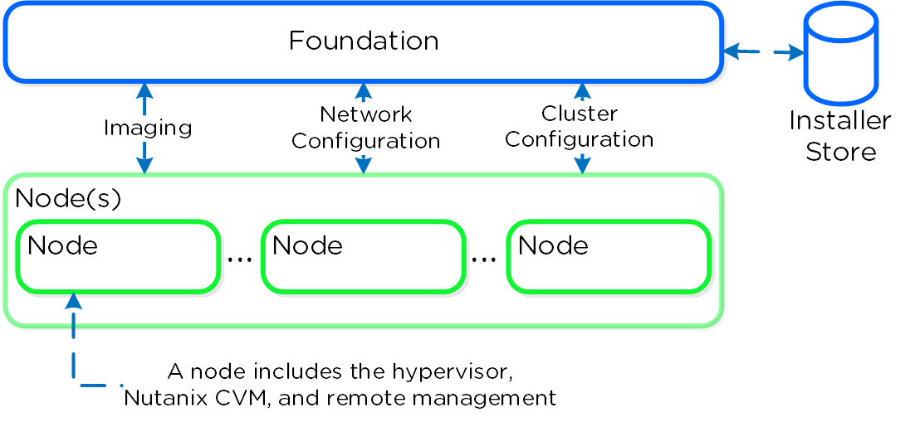
- Foundation Architecture
As of 4.5, Foundation is built into the CVMs to simplify configuration. The installer store is a directory for storing uploaded images, these can be used for the initial imaging as well as cluster expansion when imaging is required.
The Foundation Discovery Applet (which can be found HERE) is responsible for discovering nodes and allowing the user to select a node to connect to. Once the user has selected a node to connect to, the applet will proxy localhost:9442 IPv4 to the CVM’s IPv6 link-local address on port 8000.
The figure shows a high-level view of the applet architecture:

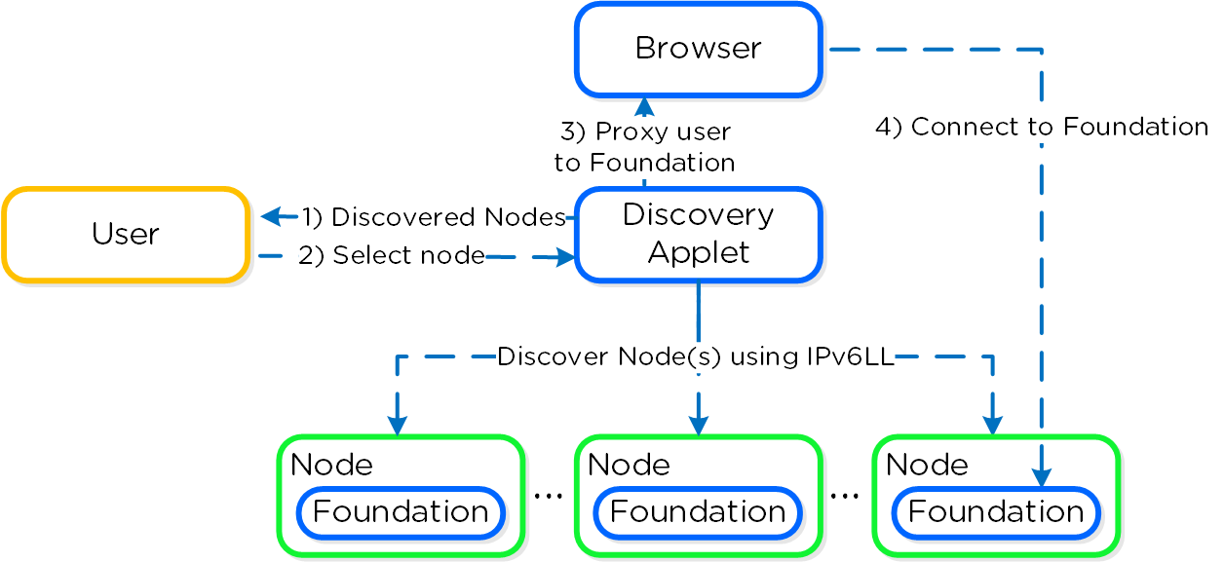
- Figure: Foundation Applet Architecture

The Foundation tool has the following configuration inputs (below). A typical deployment requires 3 IP addresses per node (hypervisor, CVM, remote management (e.g. IPMI, iDRAC, etc.)). In addition to the per node addresses, it is recommended to set a Cluster and Data Services IP addresses.

Cluster | CVM | Hypervisor | IPMI
Name | IP Per CVM | IP per hypervisor host | IP per node
IP | Netmask | Netmask | Netmask
NTP | Gateway | Gateway | Gateway
DNS | Memory | DNS*
 |  | Hostname prefix

- Cisco HCI M7 servers
The Cisco UCS C220 M7 Rack Server is a versatile general-purpose infrastructure and application server. This high-density, 1RU, 2-socket rack server delivers industry-leading performance and efficiency for a wide range of workloads, including virtualization, collaboration, and bare-metal applications.
The Cisco UCS C220 M7 Rack Server extends the capabilities of the Cisco UCS rack server portfolio. It incorporates the 4th and 5th Gen Intel® Xeon® Scalable Processors with 50 percent more cores per socket, advanced features such as Intel Advanced Matrix Extensions (AMX), Data Streaming Accelerator (DSA), In-Memory Analytics Accelerator (IAA), and QuickAssist Technology (QAT). Many applications will see significant performance improvements.
The C220 M7 rack server brings many new innovations to the UCS rack server portfolio. With the introduction of PCIe Gen 5.0 for high-speed I/O, a DDR5 memory bus, and expanded storage capabilities, the server delivers significant performance and efficiency gains that will improve your application performance.
- Supports up to two 4th or 5th Gen Intel Xeon Scalable CPUs, with up to 60 cores per socket.
- Up to 32 DDR5 DIMMs for up to 4 TB of capacity using 128 GB DIMMs (16 DIMMs per socket).
- Up to 5600 MT/s DDR5 memory plus other speeds depending on the CPU installed.
- Up to 3 PCIe 4.0 slots or up to 2 PCIe 5.0 slots, plus a modular LAN on motherboard (mLOM) slot.
- Support for Cisco UCS VIC 15000 Series adapters as well as third-party options.
  - Up to 10 SAS/SATA or NVMe disk drives.
  - New tri-mode RAID controller supports SAS4 RAID or NVMe hardware RAID with optional up to four direct-attach NVMe drives.
  - Option for 10 direct-attach NVMe drives at PCIe Gen4x4 each.
- M.2 boot options.
- Up to two 960GB SATA M.2 drives with hardware RAID, or
- Up to two 960GB NVMe M.2 drives with NVMe hardware RAID
- Up to three GPUs supported
- Hybrid modular LOM/OCP 3.0
- One dedicated Gen 4.0 x16 slot that can be used to add an mLOM or OCP 3.0 card for additional rear-panel connectivity.
- mLOM allows for Cisco UCS Virtual Interface Cards (VICs) without consuming a PCIe slot, supporting quad port 10/25/50 Gbps or dual port 40/100/200 Gbps network connectivity.
- OCP 3.0 slot features full out-of-band management for select adapters.

- Cisco UCS Manager
- Cisco Intersight
- Nutanix Move

Prism Central Configuration
Prism Central (PC) Multi-cluster manager responsible for managing multiple Nutanix Clusters to provide a single, centralized management interface. Prism Central is an optional software appliance (VM) which can be deployed in addition to the AOS Cluster (can run on it).
it can be used to monitor performance, health, and inventory for all clusters, and is recommended for larger deployments with multiple clusters or sites. Prism Central is hypervisor-agnostic and can manage clusters running different hypervisors.
Prism Central is included with every Nutanix deployment in a standard version, and is also available as a separately licensed Nutanix Cloud Manager Intelligent Operations version. It runs as a separate instance that can be a single VM or a three-VM scale-out architecture. Prism Central supports the following authentication providers:
- Prism Element (PE)
- Local
- Active Directory
- LDAP
- SAML Authn (IDP)
- SAML / 2FA Prism Central
Prism Central Configuration
Prism Central IP Address | 10.240.251.70
User name | Admin
Admin Password | P@ssw0rd
Cluster Name | Dhan_AHV
Network Services
DNS Server(s) | 10.240.251.71,10.240.251.10
NTP Server(s) | Will be using Node IP Address
Time Zone | India - NewDelhi, Kolkata

DOS AND DON’TS IN CISCO UCS NUTANIX ENVIRONMENT
- Frequent changes in NTP – You can change the NTP, but make sure to update the NTP in all the CVMs, UCSM . Failure to which can cause downtime with cluster in case of node reboot.
- Mitigation of all errors which is getting notified in UCS manager and Intersight.
- Password change is mandatory once the deployment handover is done.
- Take necessary backups of the settings before making any changed to the production environment.
- When you are planning to add additional uplinks, make sure to take required down time. Adding uplink without taking VLAN mapping to consideration will cause downtime in the environment.
- In a virtualized environment overprovisioning is expected, but make sure to reclaim the resources that not no-longer in use.
- Any affinity rules in place, always make a note of it and explain the rule to the engineer who is going to perform the upgrade in the cluster
- Do not shutdown Storage controller VMs.
- Periodically check the cluster health.
- Foundation upgrade can be perform ed post the cluster health and service verification only.
- When you plug out any HDD, make sure to put it back in the same slot. The HDD in one slot cannot be used in another slot in the cluster.
- Capacity disk maintenance is a hot swap activity. But System and Cache disk involved downtime.
- When you add capacity disks to the cluster, make sure to add them in a uniform manner in all nodes.
- Any node related maintenance (hardware) needs to be done through the PRISM. Nodes that need to be put in maintenance mode first before shutting down the system. In this way the cluster will be aware of the storage removal from the cluster.

INTERSIGHT

Introduction
Cisco Intersight is a cloud operations platform that consists of optional, modular capabilities of advanced infrastructure, workload optimization, and Kubernetes services. Cisco Intersight infrastructure services include the deployment, monitoring, management, and support of your physical and virtual infrastructure. It supports Cisco Unified Computing System (Cisco UCS) and Cisco Nutanix hyperconverged infrastructure (HCI), and other third-party Intersight-connected targets. The level of functionality may vary by target type.
With Intersight, you get all the benefits of SaaS delivery and full lifecycle management of distributed Intersight-connected servers and third-party storage across data centers, remote sites, branch offices, and edge environments. This empowers you to analyze, update, fix, and automate your environment in ways that were not possible with prior generations’ tools. As a result, your organization can achieve significant TCO savings and deliver applications faster in support of new business initiatives.
The Intersight platform works in conjunction with Cisco UCS Manager, Cisco Integrated Management Controller (IMC), and Cisco Nutanix Cluster. You can simply associate a model-based configuration to provision servers and associated storage and fabric automatically, regardless of form factor. Using profiles, IT staff can consistently align policy, server personality, and workloads. These policies can be created once and used to simplify server deployments, resulting in improved productivity and compliance, and lower risk of failures due to inconsistent configuration. In addition, Cisco provides integrations to third-party operations tools, starting with ServiceNow, to allow customers to use their existing solutions more efficiently.
Cisco Intersight offers flexible deployment either as Software as a Service (SaaS) on Intersight.com or running on your premises as Cisco Intersight Virtual Appliance. The virtual appliance provides the benefits of Cisco Intersight while allowing more flexibility for those with additional data locality and security requirements. The Cisco Intersight connected Virtual Appliance software can be deployed on premises, allowing users to take advantage of the SaaS functionality. The Private Virtual Appliance can be deployed on premises with further security restrictions. Click here to access the Appliance Help Center content. Intersight Regions
Cisco Intersight supports two regions: the existing North America region (us-east-1) and the Europe, Middle East and Africa (EMEA) region (eu-central–1).
Benefits include:
• Compliance: Multi-region support helps meet local regulatory requirements such as control, confidentiality of personal & sensitive data, availability, and service resilience.
• Improved performance and latency: Deployments can use an Intersight instance closer to the geographic location of users and devices.
• Seamless connection and configuration: No new workflows are required. All regions include the same familiar Intersight configuration and management experience. Connection and configuration changes are also the same in all regions.
• Data sovereignty with the same user experience: The Intersight EMEA user experience is the same in all regions. Users are automatically redirected to their account's region to maintain data sovereignty requirements.
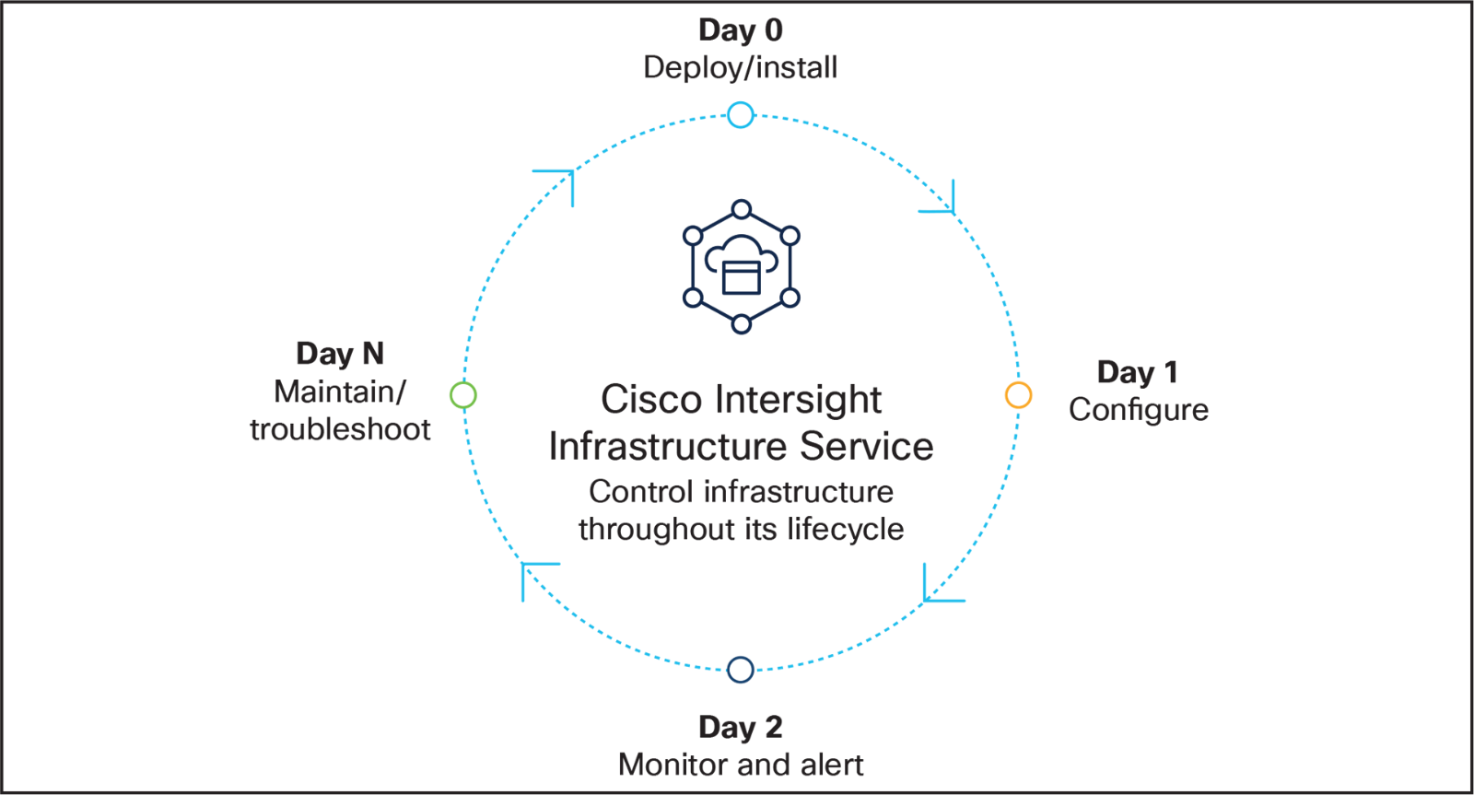
- Solution Diagram - Intersight

1.1 Target Claim
To claim a new target, do the following:
1. Log into Intersight with the Account Administrator, Device Administrator, or Device Technician privileges.
2. From the Service Selector drop-down list, select System.
3. Navigate to ADMIN > Targets > Claim a New Target.
4. Choose Available for Claiming and select the target type you want to claim. Click Start.
5. Enter the required details and click Claim to complete the claiming process.

Nutanix Move
Nutanix Move is an enterprise grade tool for transferring VMs from ESXi environments to AHV environments. Nutanix Move is a VM appliance, typically hosted on the target AHV cluster. Several software services come together to build Nutanix Move, but we can group them into the following major software components:
- The management server
- Agents for source and target
- Disk readers and writers.
The architecture for each source environment that Move uses is slightly different, but Nutanix makes the difference in implementation invisible to users.
Port Opening for Nutanix Move
IP Address for Nutanix Move Workload | 10.240.251.94
Subnet Mak | 255.255.255.128
Gateway | 10.240.251.1
Primary DNS | 10.240.251.71
Secondary DNS | 10.240.25.10

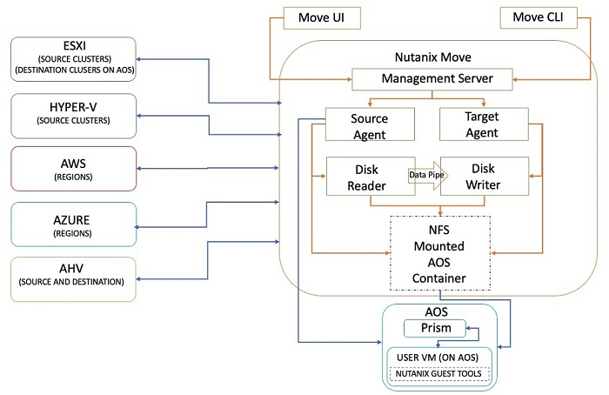
- Nutanix Move Architecture

Management server
The management server maintains source and target cluster information, as well as migration plan details and current status. It also allows APIs and the UI to create and manage migration plans.

Agents for source and target
The source agent is a platform-specific (ESXi, Hyper-V, AHV, or cloud) software component that schedules migration copy requests through disk readers. It collects source cluster and VM details and helps you select the VMs to migrate using the management server UI.
The target agent collects and keeps inventory information for the target cluster, allowing you to create migration plans. It also mounts the container in the target to prepare the disk writer to copy the data. At cutover, the target agent converts disk formats to support AHV.

Disk readers and writers
Disk reader processes use source-specific APIs to read data and coordinate with disk writer processes to complete outstanding copy operations. The disk reader checkpoints copy operations to handle failures and resume operations as needed.

Nutanix Move for ESXI
The architecture of Nutanix Move for ESXi uses vCenter for inventory collection and vSphere Storage APIs for Data Protection (VADP), the Virtual Disk Development Kit (VDDK), and Changed Block Tracking (CBT) for data migration.

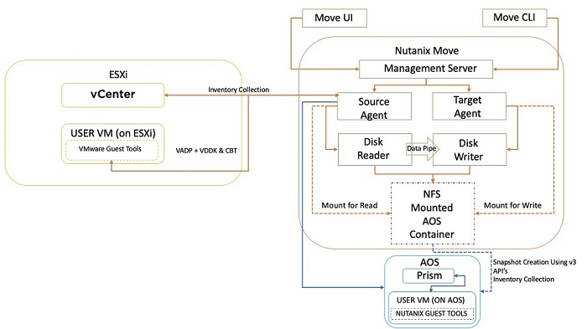
- Nutanix Move for ESXi

Migration Using Nutanix Move
To use Nutanix Move for migration, follow these steps:
- Download the Move image and launch it as a VM from the Prism console of a target cluster.
- Register your environments (ESXi, Hyper-V, AWS, Azure, or AHV) with Move as migration sources and targets.
  - To register an AHV environment, connect to the AHV cluster (Prism Element) or to a Prism Central instance name or IP address with the appropriate credentials.
  - To register an ESXi environment, connect to your vCenter instance and supply the name or IP address and the appropriate credentials.
Once you have defined your environments, you can create migration plans. Plans enable migrations to target a subset of VMs in a source.
Move checks that the target environment has enough compute and storage resources to support the VMs added to a migration plan. Move can sort VMs by whether you can migrate them and provides a summary to indicate why you can't migrate certain VMs (for example, if the VM doesn't have VMware tools installed or doesn't meet virtual hardware version level minimums). Move supports the same virtual guest operating systems that AHV supports.
For ESXi sources, Move uses VMware VADP to manage the replication process, so you don't need to install agents in the VMs or the ESXi hosts.
You can specify network mappings to match the source and destination networks for the VMs and set up a test network so that you can test the migration beforehand. Because the test process leaves the source VM turned on, we recommend using a nonroutable test network so that it doesn't interfere with the source VM.
Automatic preparation mode allows Move to connect to VMs directly to install the VirtIO drivers compatible with AHV and to capture network settings to carry over to the target environment. You can specify the credentials to connect to the VMs selected in a plan either for all VMs at once or individually as needed. If the target VM is migrating to ESXI, Move can uninstall the VMware guest tools from the target VM when the migration is complete.
Once you have configured the options described, the migration can seed the data to the AHV cluster. This process involves creating snapshots for each VM, then replicating the virtual disks to the specified AHV container. You can pause or abort migrations in progress at any time. Move stores the virtual files for the migrating VMs in a temporary folder and incrementally uses changed-block tracking (CBT) APIs and continued snapshot operations to keep them current.
When it's time to cut over and complete the migration, Move turns off the source VMs and disconnects the virtual NICs. Incremental data then synchronizes over to the AHV cluster. Once all data replication is complete, Move uses the AHV image service to convert the source virtual disk files to the native RAW format AHV uses. (For more details on the image service, refer to the Migration Scenario: Third-Party ESXi to Nutanix AHV section.) Because the disk formats are the same, conversion from the source virtual disk to RAW is extremely fast—each disk converts in just a few seconds, limiting downtime. Move also provides an estimated cutover time, so you can determine any maintenance window in advance.
You can choose to cut over VMs in a plan together or separately. To complete the migration, Move turns the VMs on in the target environment and removes all temporary VMDK files and converted images in the AHV image service. Although the source VMs are now turned off and disconnected from their networks, they persist in case you need them for any reason.
Move keeps track of which VMs you have migrated and which VMs remain to be transferred, so if you create additional migration plans, it's easy to know what's left to be done.
Nutanix designed Move to be intuitive, simple, and fast while reducing the risk and cost of migrations. For migrations with ESXi, Hyper-V, Azure, or AWS as the source, we recommend using Move for migrating to Nutanix AHV.
Move doesn't currently support all hypervisor environments as migration sources or non-AHV environments as targets, so heterogeneous source and target environments require other migration methods.

DOWNLOADS

CISCO UCS NUTANIX CLUSTER
Nutanix Downloads:
Download link: https://portal.nutanix.com/page/downloads?product=nos
Sl. No. | Description of Software to be downloaded | Size
1 | Standalone Foundation VM image for importing into VirtualBox or ESXi:  Foundation_VM-5.6.0.1.tar | 4.1 GB
2 | AOS Upgrade/Installer – STS :  nutanix_installer_package-release-fraser-6.7.1.8-stable159b3d174b1f49f11f28b292ad3262fbebc1811e-x86_64.tar.gz | 5.11 GB
3 | AHV Installer (ISO):  AHV-DVD-x86_64-AHV LCM Bundle ( Version: 20230302.2024 ):  lcm_ahv_el8.nutanix.20230302.2014.iso  2024.tar.gz | 1.29 GB
4 | Foundation LCM Bundle  lcm_foundation_5.6.0.1.tar.gz | 1.19 GB
5 | Move ZIP file for AHV:  move-5.2.0.zip | 1.62 GB

UCS C220 M7 Server Firmware:
Downlink Link : https://software.cisco.com/download/home/286331885/type/283850974/release/4.3(3.240043)?catid=282558030

Sl. No. | Description of Software to be downloaded | Size
1 | Cisco UCS Host Upgrade Utility - C220M7 Servers  ucs-c220m7-huu-4.3.3.240043.iso | 728.57 MB

UCSM Managed C220 M7 Server Firmware:

Downlink Link : https://software.cisco.com/download/home/283862063/type/283655681/release/4.3(3a)

Sl. No. | Description of Software to be downloaded | Size
1 | A Bundle:  The UCS Infrastructure Software Bundle contains: - NX-OS software for the  UCS 6454 Fabric Interconnects - Firmware for the fabric extenders and I/O  modules - UCS Manager - Chassis Management Controller - UCSM Capability  Catalog.  ucs-6400-k9-bundle-infra.4.3.3a.A.bin | 2602.95 MB
2 | B Bundle:  Software for the UCS B-Series blade server products  ucs-k9-bundle-b-series.4.3.3a.B.bin | 1000.14 MBs
3 | C Bundle:  Software for the UCS C-Series rack-mounted servers. This is software for UCS  Manager based C-Series management.  ucs-k9-bundle-c-series.4.3.3a.C.bin | 1806.23 MB

Nutanix Foundation VM resource requirement for deployment:
Resources | Recommended Values
CPU | 4 CPU
RAM | 8 RAM
HDD | 100 GB

